Name **Nuzhat Qureshi**

Roll No BIT-24S-029

Github link <https://github.com/NuzhatQureshi90/Pythons-lab-manual-IT-A-/upload/main>

**LAB MANAUL 5:**

**TASK 1:**

Q.1. Basic Task: Write a for loop to print the first 10 natural numbers.

Program:

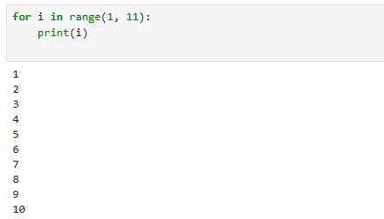

**TASK 2:**

Q.1. Intermediate Task: Write a while loop that prints numbers from 10 down to 1

Program:

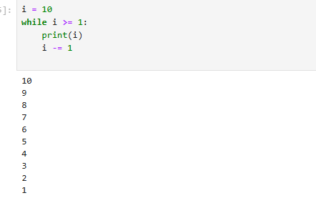

**TASK 3:**

Q.1. Advanced Task: Create a program that uses a for loop to iterate over a string and count the number of vowels.

Program:

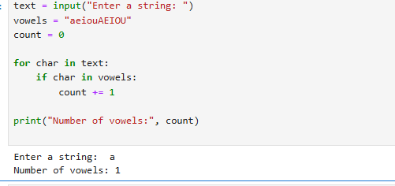

**TASK4:**

Q.1. Write a program that prints the Fibonacci series up to n terms using a while loop.

Program:

